# Curriculum Vitae (CV)

**Mr. SYED IQBAL AHMAD RAHMANI** 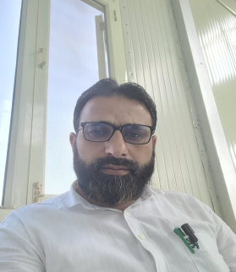

Parentage: Syed Gh Hassan Rahmani

Residence: Onagam Bandipora-193502

Qualification: M.A, B.ed, UGC NET

Designation: Assistant Professor

Department of Arabic, Govt. Degree College

Handwara -193221

Contact: Email: [iqbalrahmani@gmail.com](mailto:iqbalrahmani@gmail.com)

Mobile: +918803082419, +919419037223

**Brief academic profile**:

* **B. A** from Nadwa College, Lucknow (2003)
* **M.A** Arabic from University of Kashmir, Srinagar (2005)
* **B. Ed** from University of Kashmir, Srinagar (2009)

**Academic/Research achievement:**

* Qualified **UGC-NET**in the subject of ***Arabic*** 2006.

**Courses attended:**

1. Attended 30 days 80st General Orientation Course at University of Kashmir (12 Nov -13 Dec 2018).
2. Attended 3 Days course on “Role of National Service scheme in Disaster Management” at J&K Institute of Management Public Administration and Rural Development Srinagar (22-24 April 2019).
3. Attended 7 days Induction Training Programme for newly Recruited Assistant Professors in Education Department of Higher Education Organized by Institute of Advanced Studies in Education Srinagar (-16 Feb 2017).
4. Attended National level one week FDP on E- learning
5. Participated in one week Virtual FDP on E-learning tools for MOOC (June 2020)
6. Attended 3 week FDP on “Effective use of online teaching platform, Essentials of MS Office” (September 2020)
7. Participated in the 1st Online Refresher Course in LANGUAGES (OCTUBER 2020)
8. Participated in the Three-Day International Webinar on Post COVID-19 (JUNE 2020)
9. Participated in Online Refresher Course in Oriental Studies Organized by AMU ( November 2024)

**Teaching Experience:**

* Eight years teaching Experience at under Graduate level

**Work Experience:**

1. Worked as General line teacher in School Education department for nine years (2007-16).

**Seminars and Workshops Attended:**

1. Attended 2 days Seminar on impact of Arabic on Indian languages in the departments of Arabic Kashmir University .
2. Attended 46th session of All Indian Oriental conference in the department of Sanskrit University of Kashmir .